**Visualization**

**User Manual**

Cady Pridgeon

Amee Kivette

Keanna Tennyson

Laura Wilson

### 

#### COMP 4710 Senior Design Project #3 Team Orange

Department of Computer Science and Software Engineering

Samuel Ginn College of Engineering, Auburn University

April 26, 2024

**Table of Contents**

**1. Introduction 3**

1.1. Project Overview 3

1.2. User Manual Purpose 3

**2. Getting Started 3**

**3. Interface 3**

**4. Functionality 5**

4.1. Chronology: Authors 5

4.1.1. Navigate Visualization 6

4.1.2. View Tooltip 6

4.1.3. Access Details Page 8

4.1.4. Sort Data 9

4.1.5. Filter Data 12

4.1.6. Change View 13

4.2. Sunburst: Authors & Books 14

4.2.1. Navigate Visualization 14

4.2.2. View Tooltip 16

4.2.3. Access Details Page 18

4.2.4. Export Visualization 20

4.3. Heatmap: Books 22

4.3.1. Navigate Visualization 23

4.3.2 View Popover 24

4.3.3 Access Book Cover Image and Details Page 24

**5. Tutorials 2****5**

# **Introduction**

## **Project Overview**

The Alabama Authors of the 19th and 20th Centuries is a digital humanities project created by Dr. Beverley Park Rilett. This online resource provides access to information about Alabama authors and their published literature. Over a semester, the COMP 4710 Senior Design Project #3 Team Orange contributed three data visualizations to the Alabama Authors website. These visualizations allow users to explore the wealth of data on the website at a glance, facilitating robust data exploration capabilities.

## **User Manual Purpose**

This User Manual aims to provide users with a thorough walkthrough of the new features added to the Visualizations facet of the Alabama Authors website. Details regarding how to access the Alabama Authors website, navigate the visualizations, and troubleshoot common errors are outlined in this manual. If there are any questions regarding the visualizations or the website, please contact Dr. Beverly Park Rilett, Project Sponsor and Founder, at [bdr0032@auburn.edu](mailto:bdr0032@auburn.edu).

# **Getting Started**

To access the Alabama Authors website, navigate to <https://alabamaauthors.org/> in any web browser. The website is accessible from both mobile and desktop devices, but data visualization functionality is optimized for desktop usage. Data visualizations were developed and tested on Google Chrome, so functionality on other browsers may vary.

# **Interface**

After navigating to the Alabama Authors website, users are taken to the home page. This landing page provides a brief overview of the project.

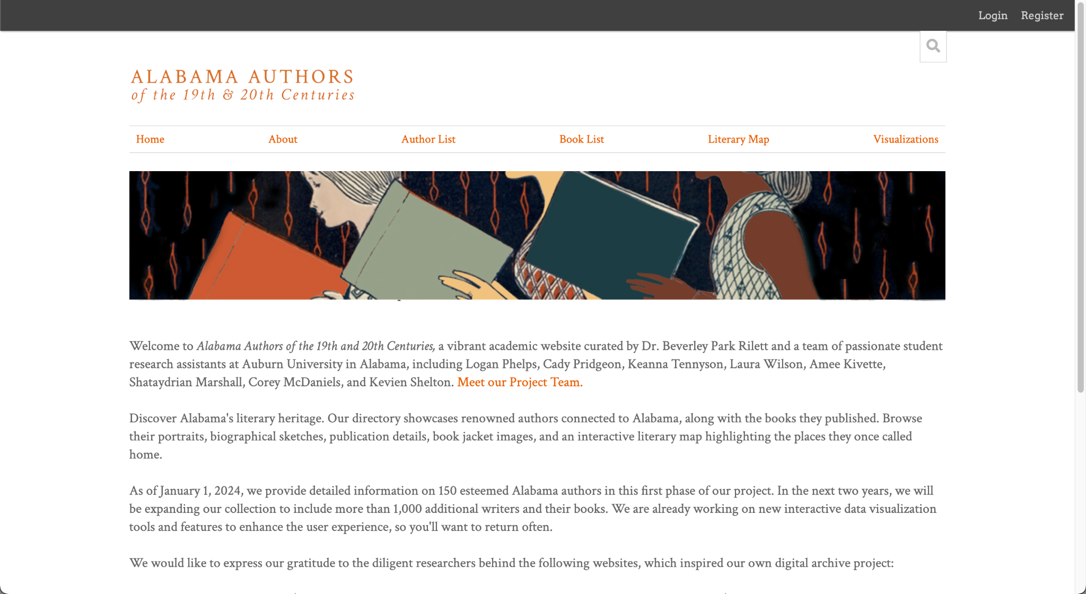

**Figure 1. Alabama Authors Home Page**

On the navigation bar, users can view the following sections: Home, About, Author List, Book List, Literary Map, and Visualizations. The About page contains information about the project team. Author List displays a table of the authors found in the Alabama Author Collection on the website. Similarly, the Book List page displays a table of book publications found in the Alabama Author Book Publication Collection. The Literary Map contains a Neatline heatmap visualization that plots authors by county on an interactive map of Alabama. Finally, the Visualizations tab contains three interactive data visualizations produced by Team Orange. This tab contains links to the Neatline book wheel (Heatmap: Books), D3.js author chronology (Chronology: Authors), and D3.js author and book publication sunburst (Sunburst: Authors & Books).

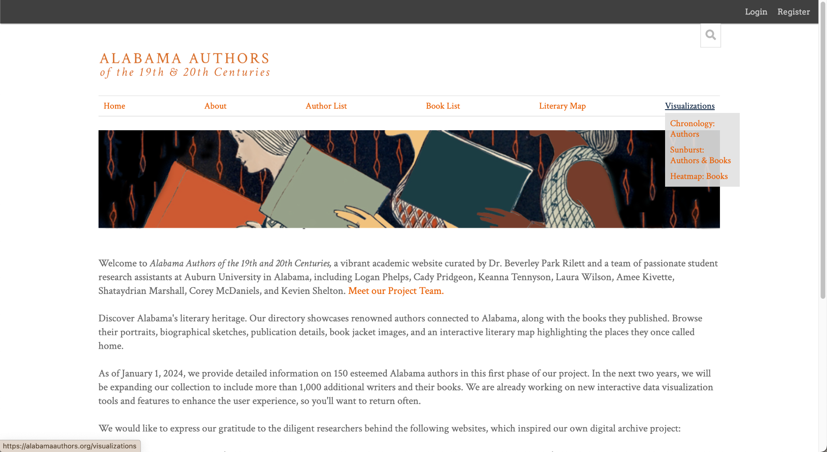

**Figure 2. Alabama Authors Visualizations Tab**

# **Functionality**

## **Chronology: Authors**

The Chronology: Authors tab takes users to the D3.js bar chart chronology visualization that depicts authors on a timeline based on their birth and death years.

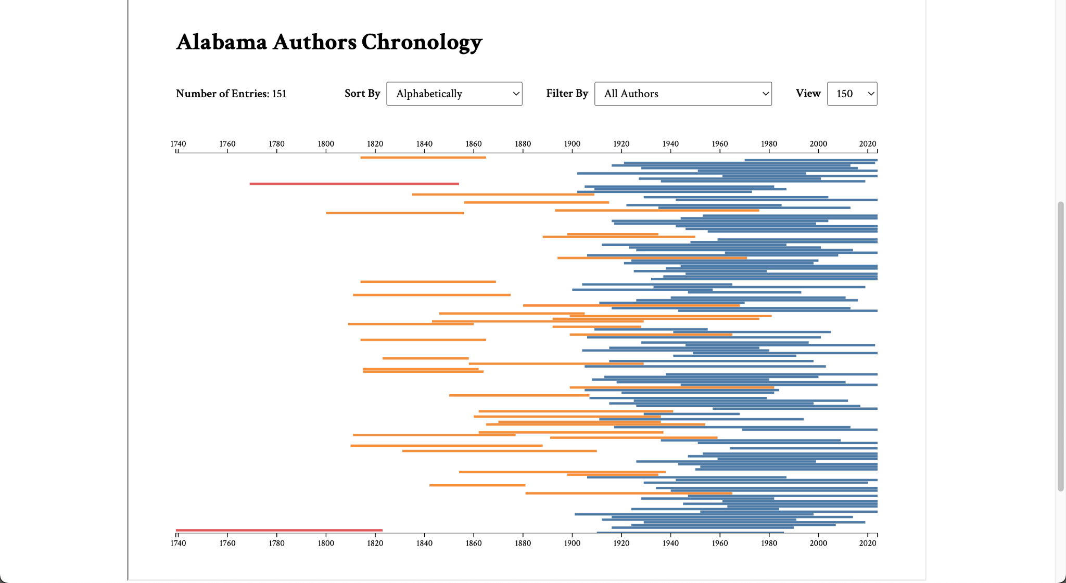

**Figure 3. D3.js Authors Chronology**

### Navigate Visualization

To navigate the chronology, users can use their trackpad to scroll to zoom in and out of the chronology bars. Scrolling down zooms in, and scrolling up zooms out. Once a user has zoomed in, they can drag up or down on their trackpad to move up and down the visualization bars.

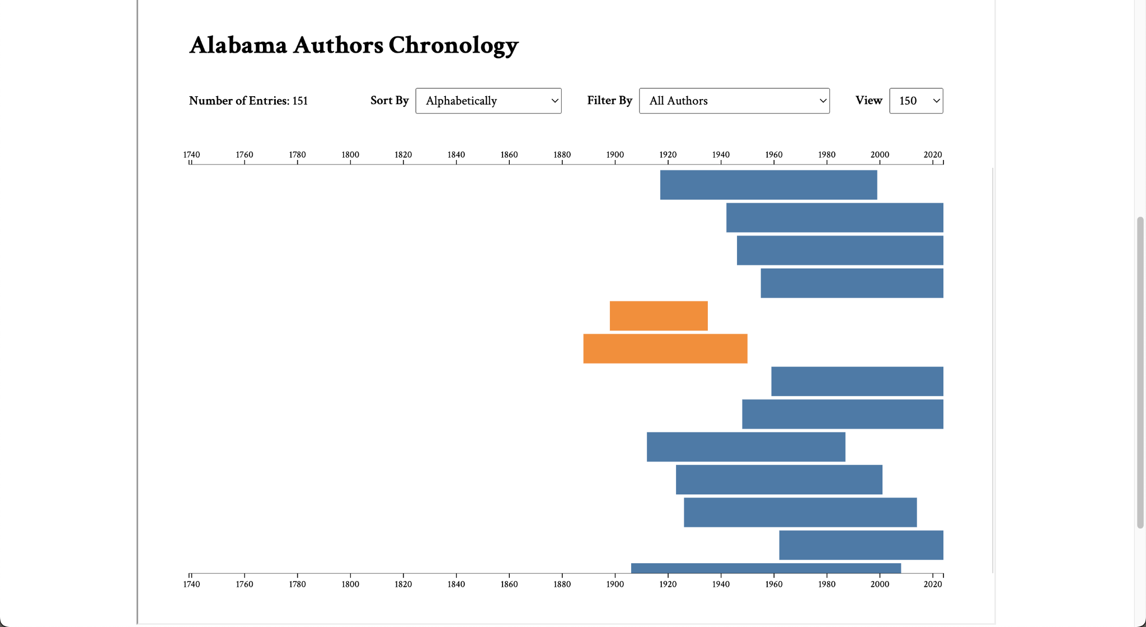

**Figure 4. D3.js Authors Chronology - Zoomed In**

Alternatively, keyboard commands may also be used to navigate the chronology. The commands support tooltip viewing and link clicking, but zoom and scrolling are not currently supported.

### View Tooltip

To view the tooltip preview, hover over a bar. The tooltip displays basic author information, such as their name, lifespan, and number of years lived. If available, an author image is also displayed.

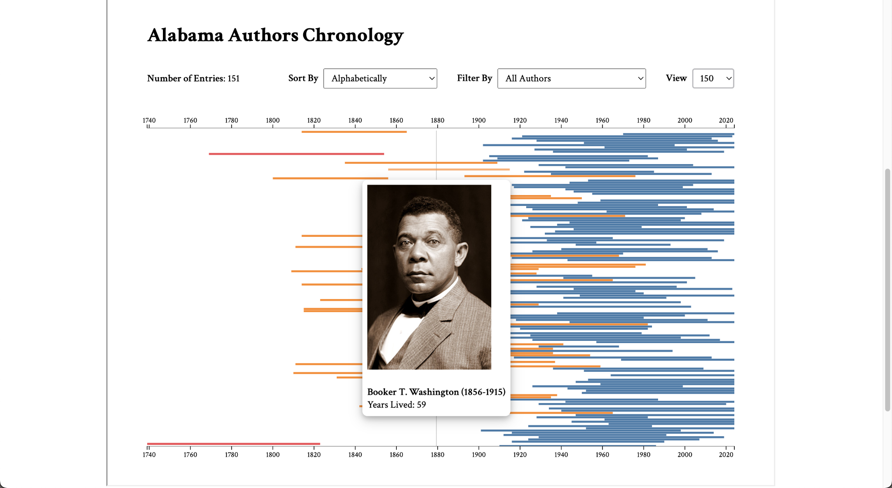

**Figure 5. D3.js Authors Chronology - Hover Tooltip**

To view the tooltip using keyboard commands, users may use the tab key on their keyboard to focus on the bars. When focused, the bars will display the tooltip.

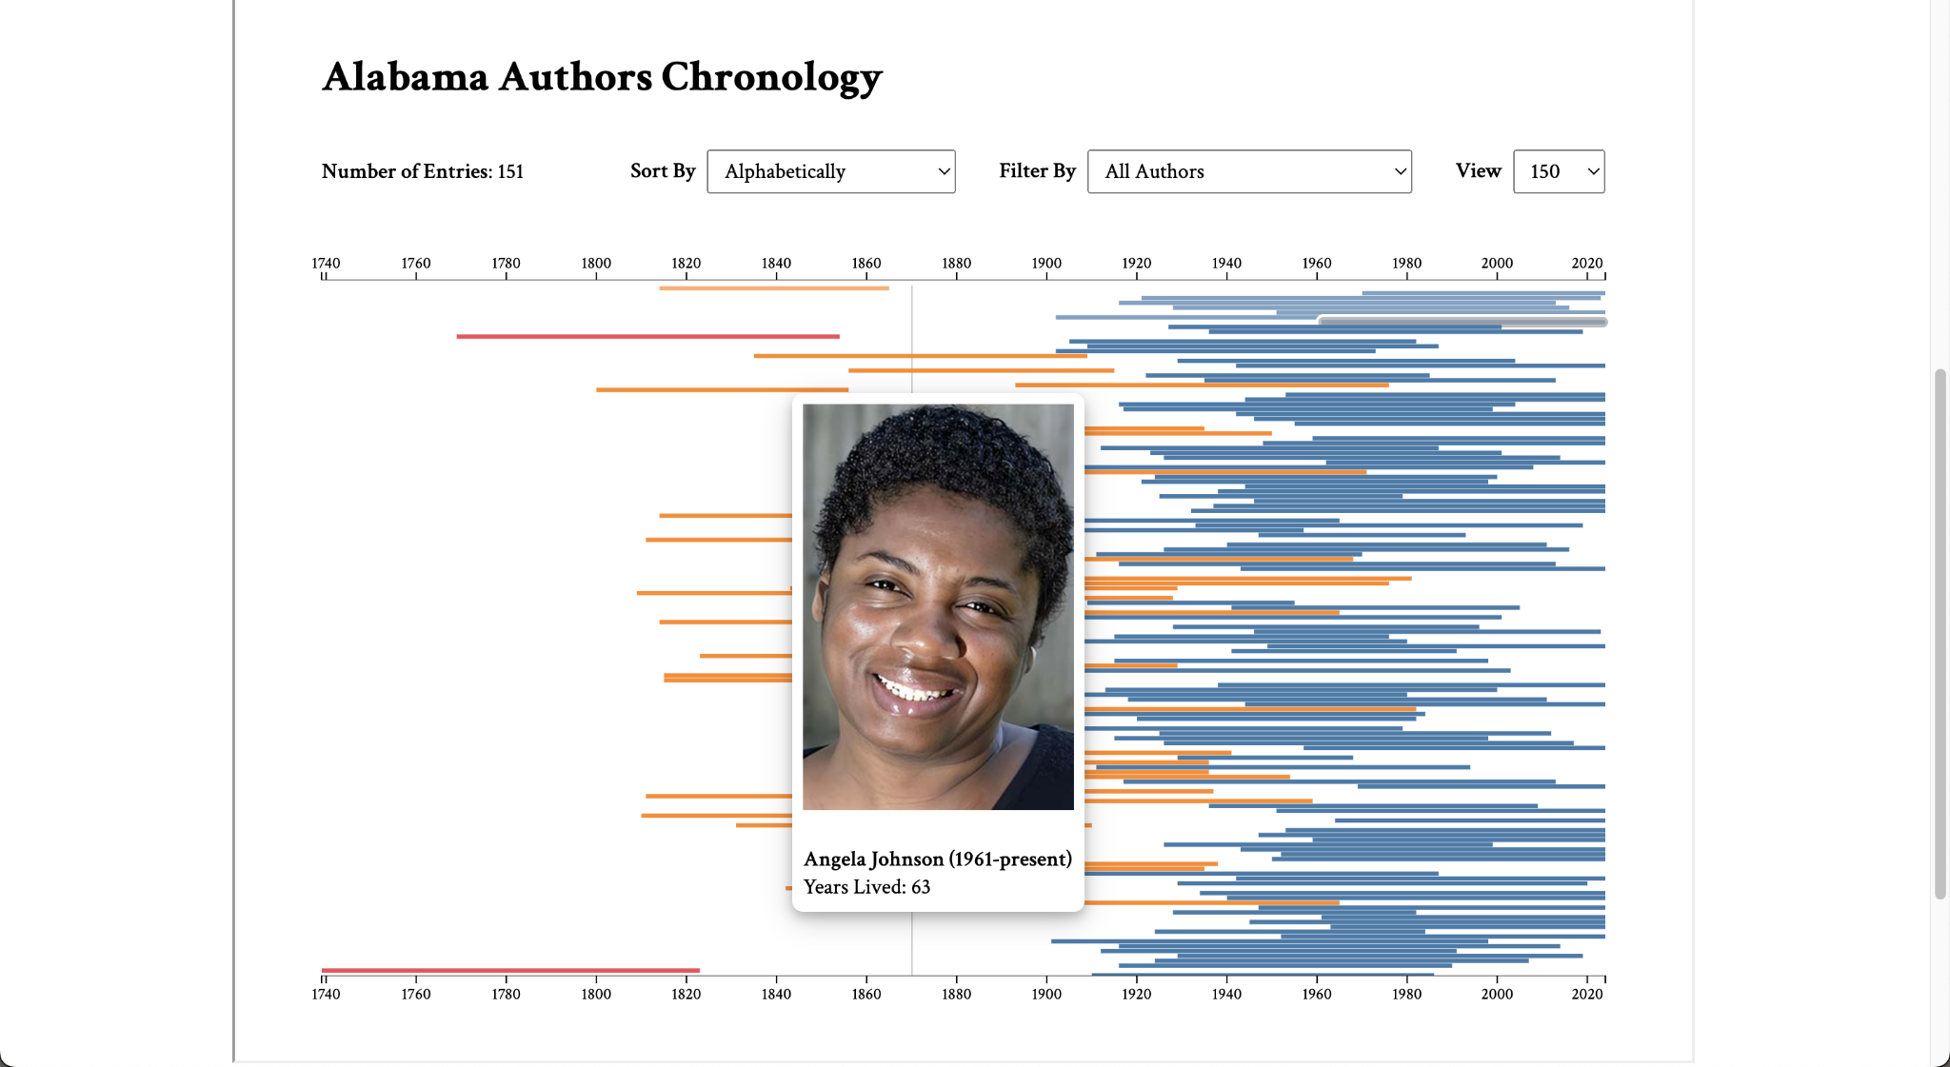

**Figure 6. D3.js Authors Chronology - Keyboard Focus Tooltip**

Tabbing will select each subsequent bar from the one currently selected. To navigate to a previous bar, users may hold shift, and then continue tabbing.

### Access Details Page

To access the author details page, users can click on a bar. This will take the user to a new tab with the associated author details page within the Alabama Authors website.



**Figure 7. D3.js Authors Chronology - Click for Author Details Page**

If using keyboard commands, users can tab to a bar, and once focused, can press the enter key on their keyboard. This will take them to a new tab with the associated author details page within the Alabama Authors website.



**Figure 8. D3.js Authors Chronology - Enter for Author Details Page**

### Sort Data

To sort the data available on the visualization, users may utilize the sort dropdown feature. This dropdown provides the following sort criteria: Alphabetically, Ascending Birth Year, Descending Birth Year, Ascending Death Year, Descending Death Year, Ascending Lifespan, and Descending Lifespan. The visualization updates according to the selected sort criteria.

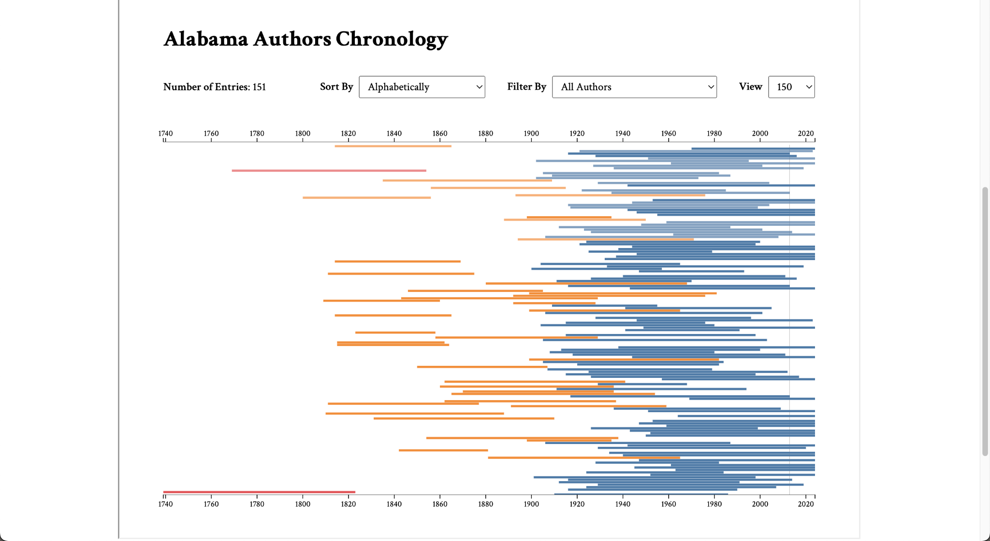

**Figure 9. D3.js Authors Chronology - Sort Alphabetically**

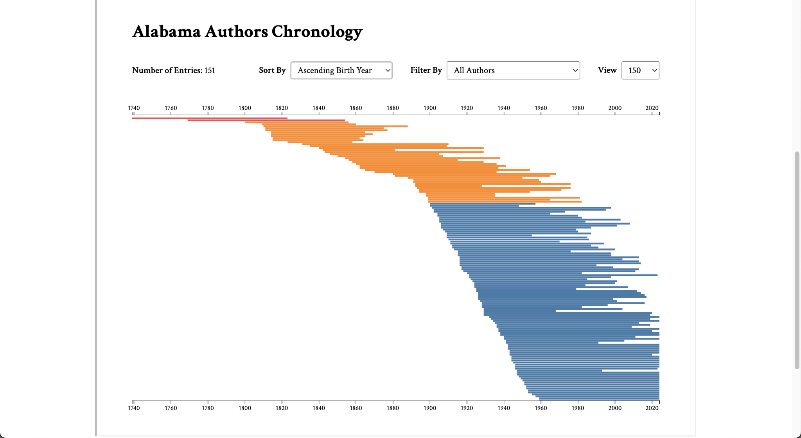

**Figure 10. D3.js Authors Chronology - Sort by Ascending Birth Year**

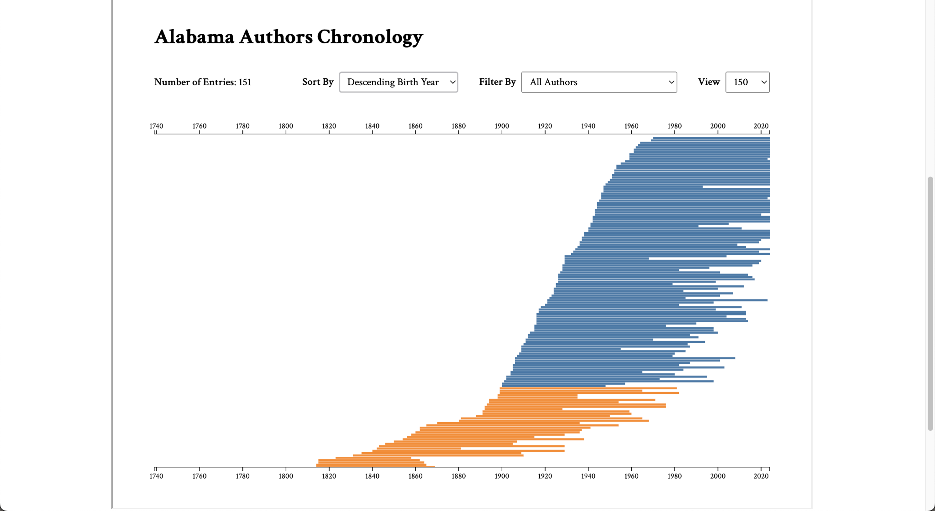

**Figure 11. D3.js Authors Chronology - Sort by Descending Birth Year**

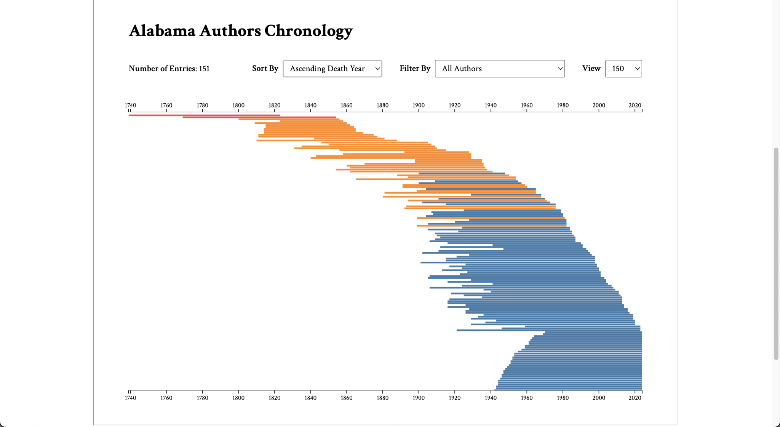

**Figure 12. D3.js Authors Chronology - Sort by Ascending Death Year**

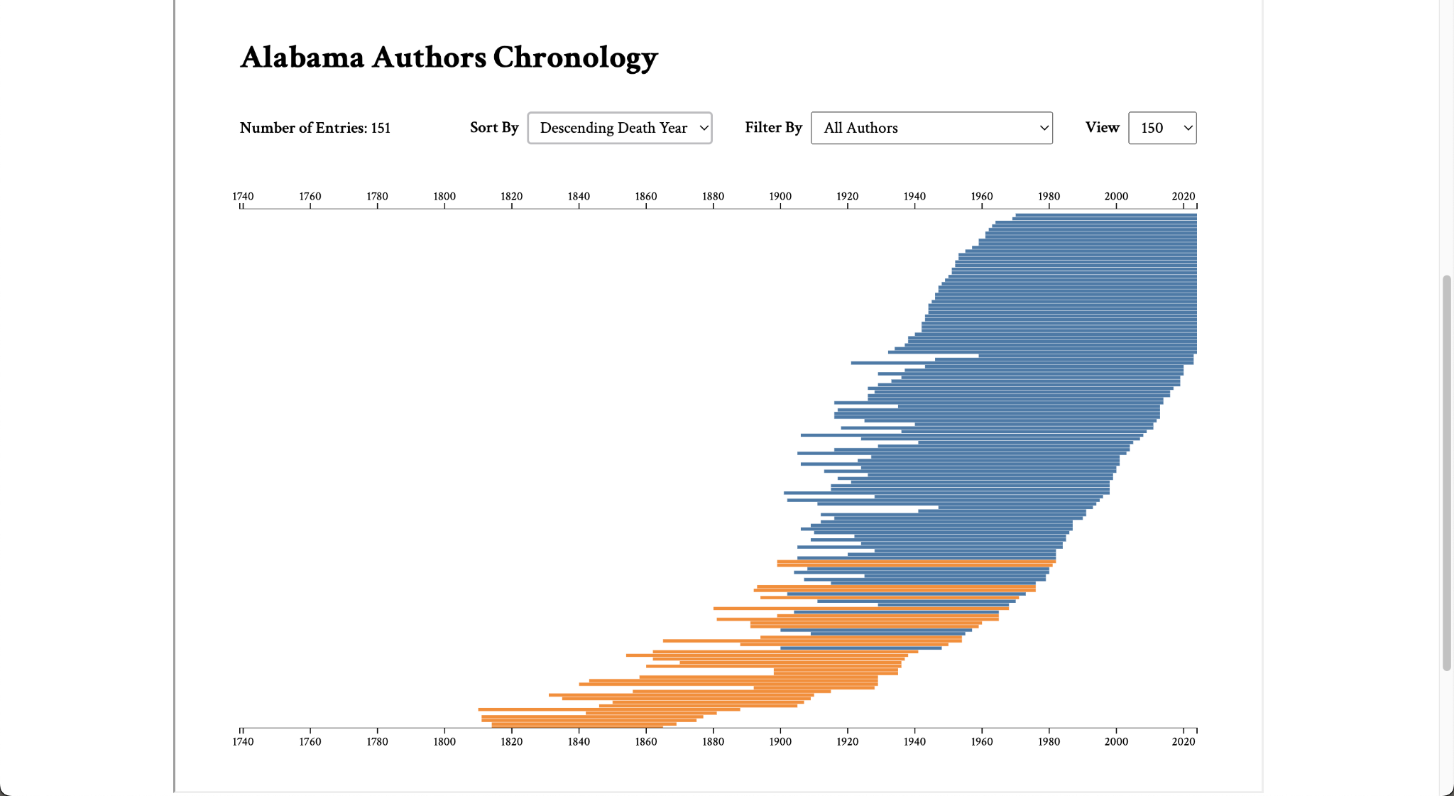

**Figure 13. D3.js Authors Chronology - Sort by Descending Death Year**

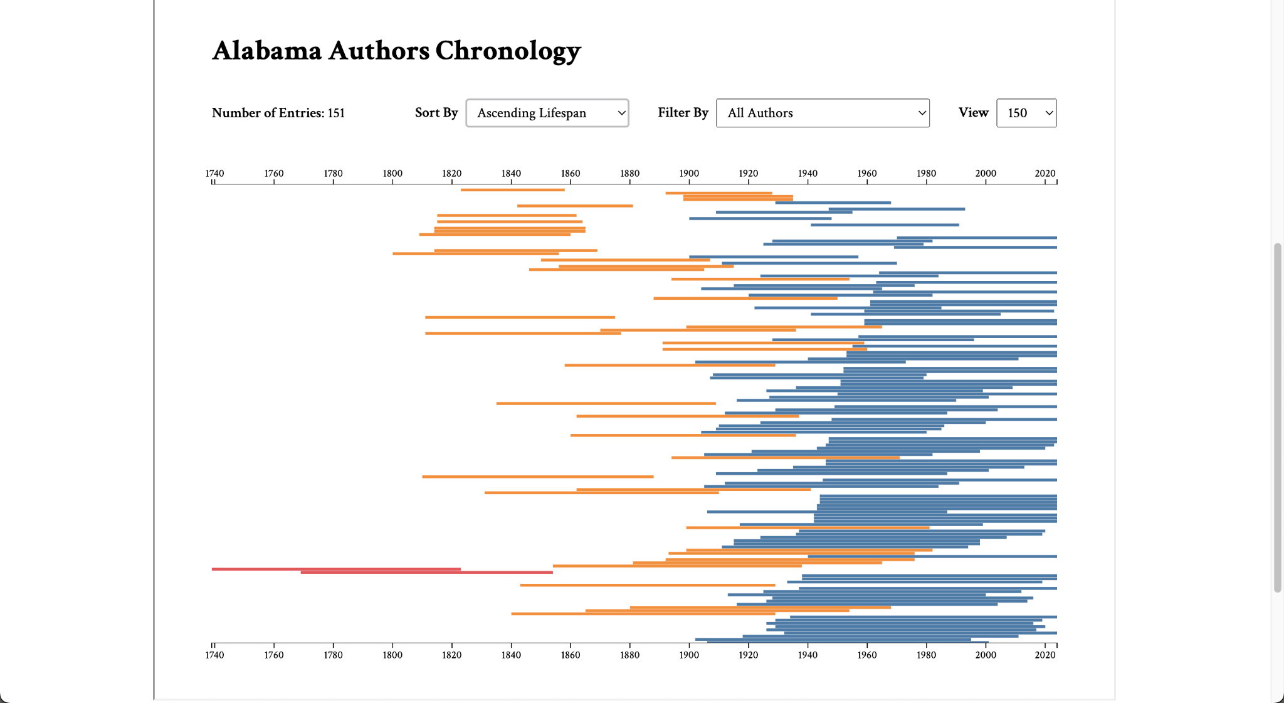

**Figure 14. D3.js Authors Chronology - Sort by Ascending Lifespan**

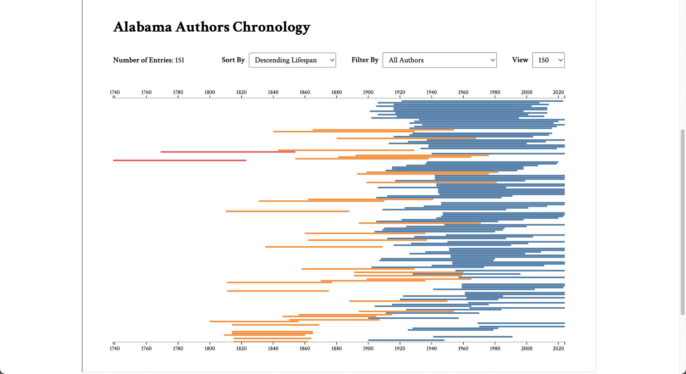

**Figure 15. D3.js Authors Chronology - Sort by Descending Lifespan**

### Filter Data

To filter the data available on the visualization, users may utilize the filter dropdown feature. This dropdown provides the following filter criteria: All Authors, Authors with Links, Authors with Images, and Authors with Links and Images.

### Change View

To change the source of the visualization data, users may utilize the view dropdown feature. This dropdown provides users with a 150 or 1700 option. These options correspond to the approximate number of data entries in each visualization. The 150 option utilizes the data from the Alabama Author collection data within the website. The 1700 option utilizes data that has been collected by the Alabama Authors research team but has yet to be incorporated into the website. The sort and filter options are more insightful on the 1700 view.

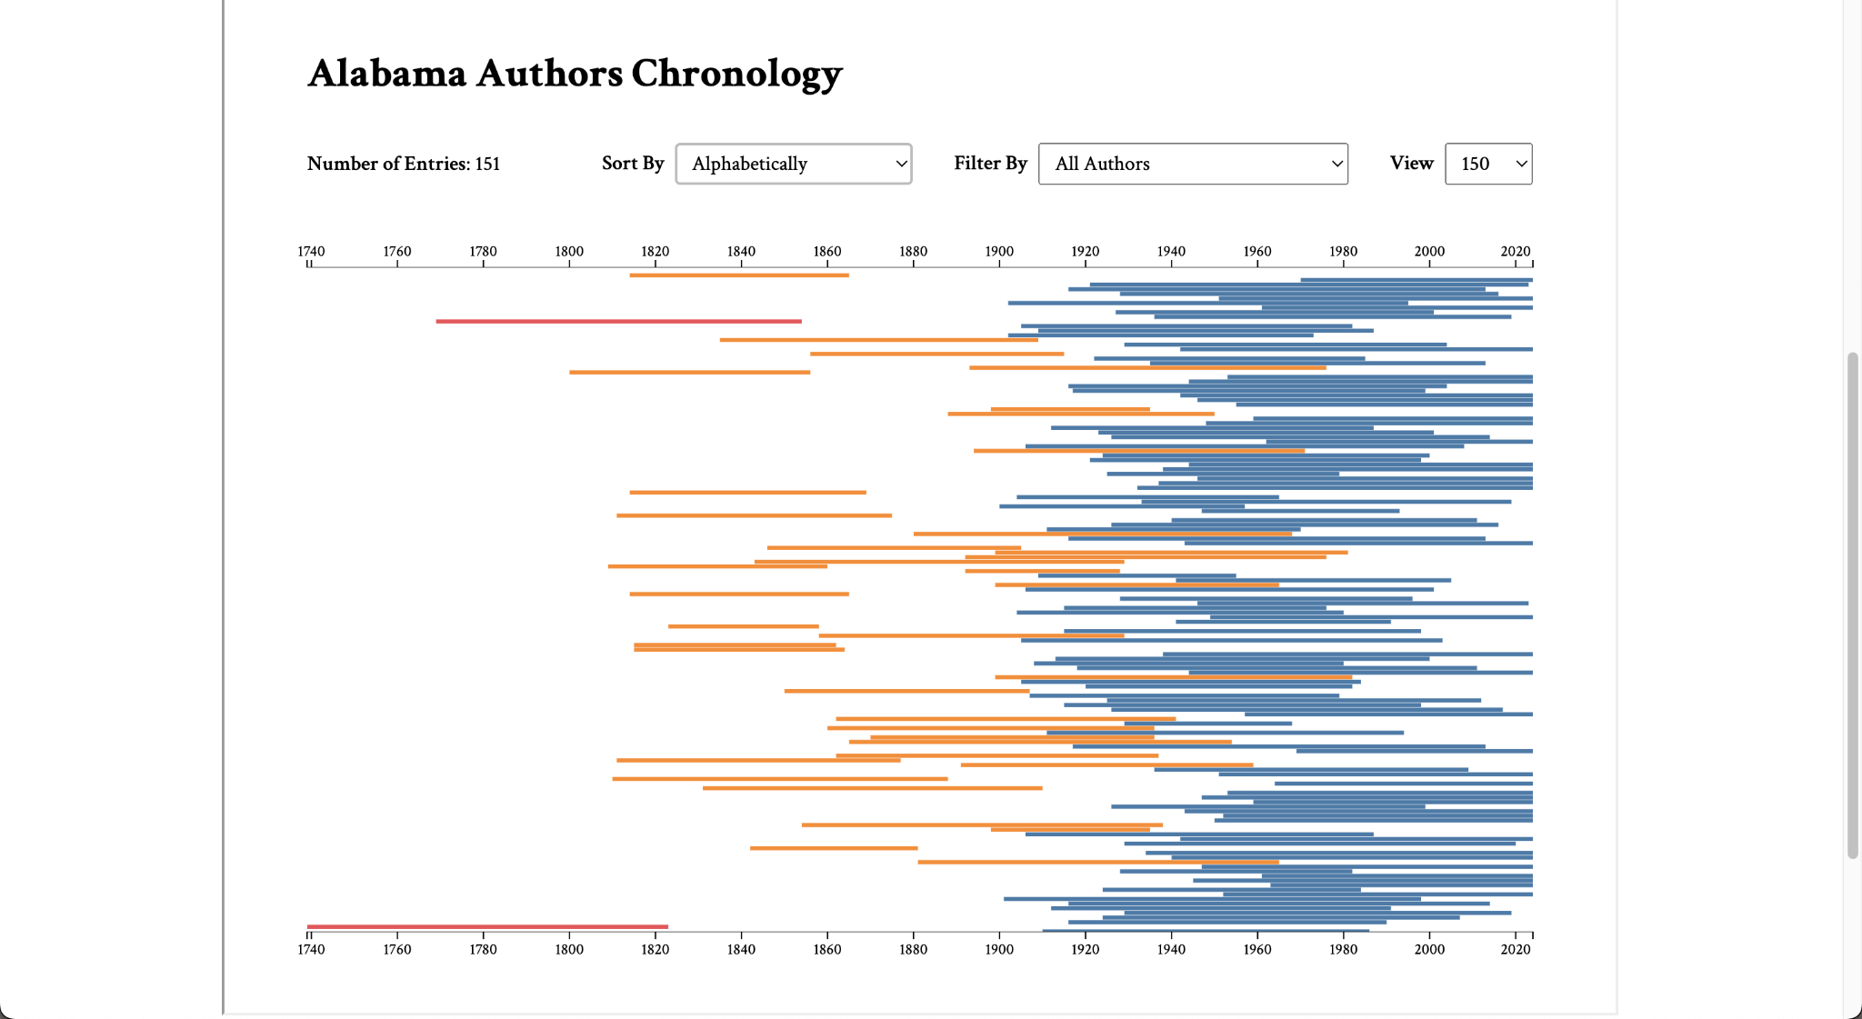

**Figure 16. D3.js Authors Chronology - 150 View**

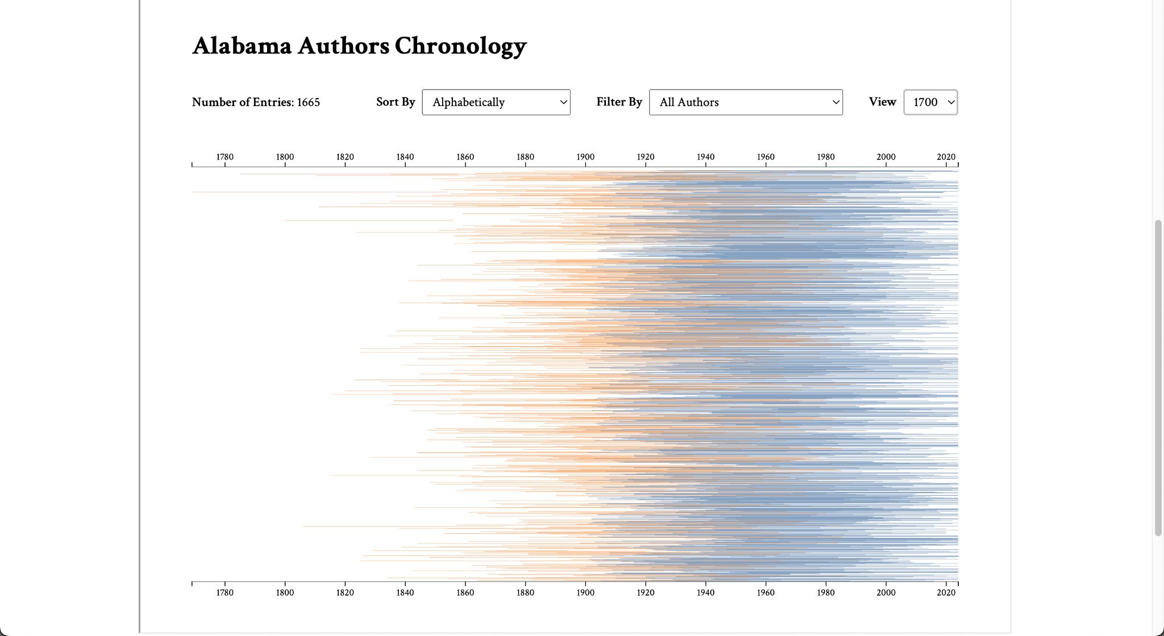

**Figure 17. D3.js Authors Chronology - 1700 View**

## **Sunburst: Authors & Books**

### Navigate Visualization

To navigate the sunburst visualization, users can click on sections of the visualization. If the section contains child data, the visualization will regenerate to display the child data. The visualization opens to the top level, which displays the centuries and some of the authors within the centuries. After clicking on a century, authors from that century, along with their book publications, become visible. If a user clicks on an author, the sunburst adjusts to show only the author’s book publications.

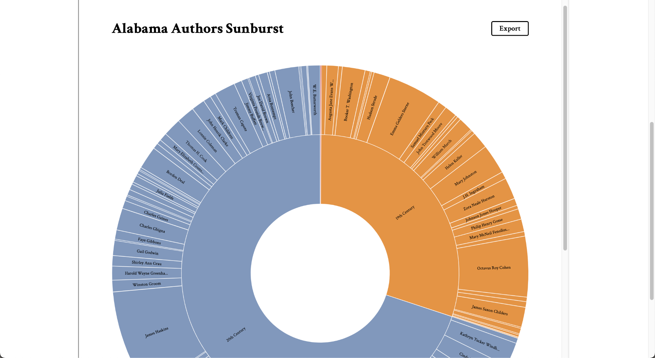

**Figure 18. D3.js Authors & Books Sunburst - Initial View**

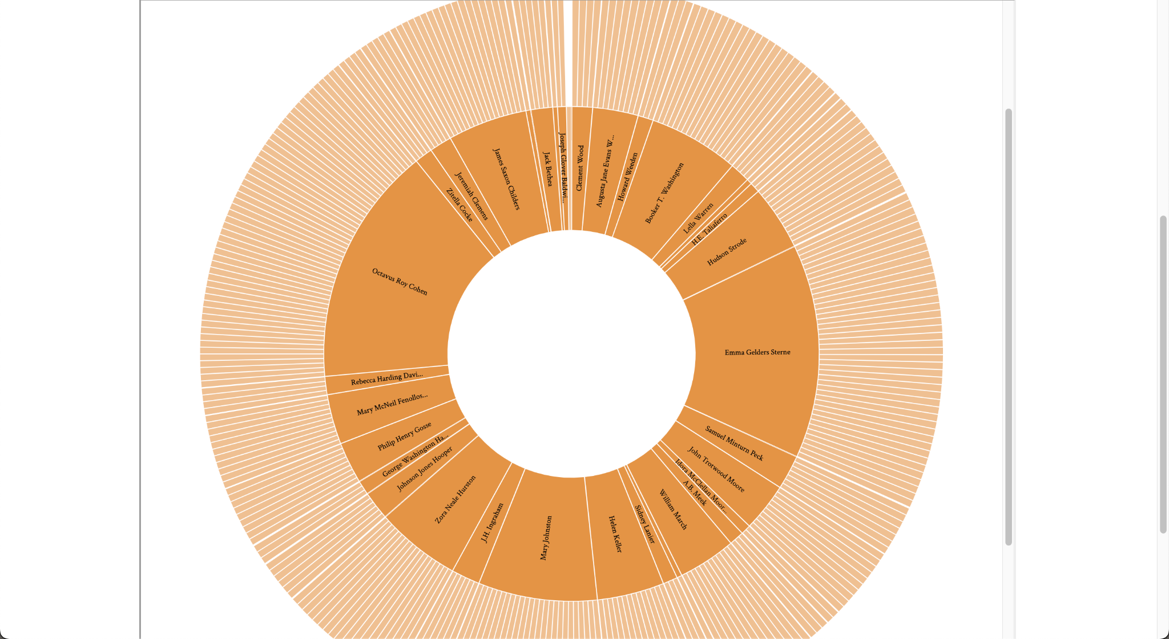

**Figure 19. D3.js Authors & Books Sunburst - 19th Century View**

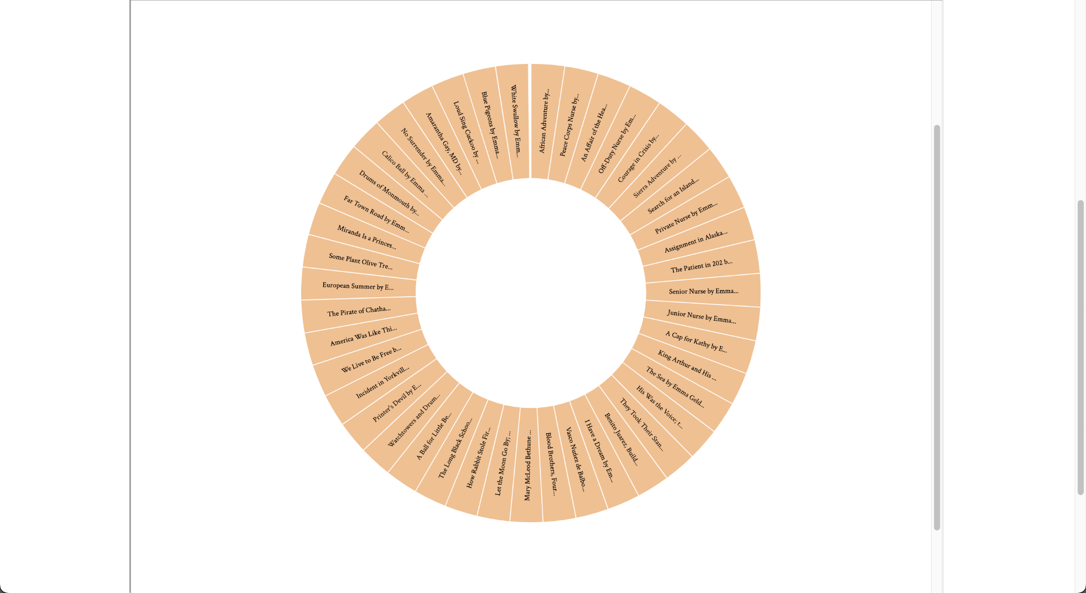

**Figure 20. D3.js Authors & Books Sunburst - Author View**

To go to the previous view in the navigation, users should click in the center of the screen. This will bring them to the parent view.

Users may also utilize keyboard commands to navigate the sunburst. Using the tab key on their keyboard, users may focus on a section they would like to drill down into. After focusing on a section, users can use the enter key to open the child view. To go back to the previous view, users can use the delete key. To tab to previously focused elements, users should hold the shift key while tabbing. Currently, the tab order is random in some areas of the visualization. The sponsor has been notified of this issue.

### View Tooltip

To view the tooltip with author and book publication information, users can hover over a section on the visualization. Author tooltips display their name, lifespan, and image. Book publication tooltips display the book title, publication year, and book cover.

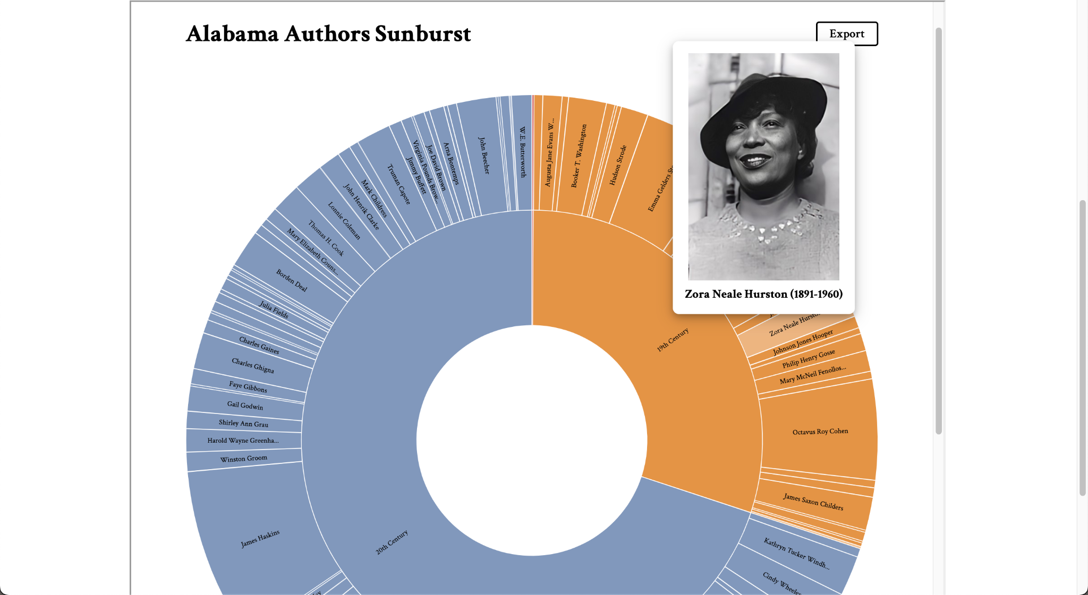

**Figure 21. D3.js Authors & Books Sunburst - Author Hover Tooltip**

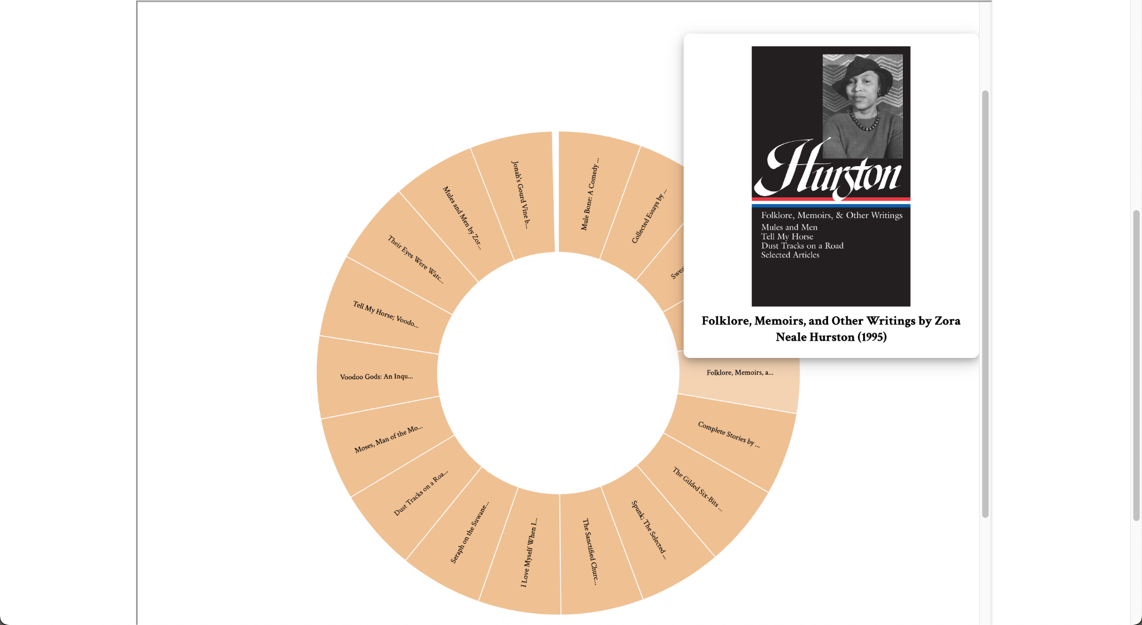

**Figure 22. D3.js Authors & Books Sunburst - Book Publication Hover Tooltip**

Keyboard commands are not currently supported for viewing author or book tooltips.

### Access Details Page

Since the visualization navigation relies on clicking on sections, a context menu was utilized to implement details page access. To access the author or book details page, users can right-click on a section and select the “Learn more” option on the context menu. This will take users to a new tab with the respective author or book publication details page on the Alabama Authors website.

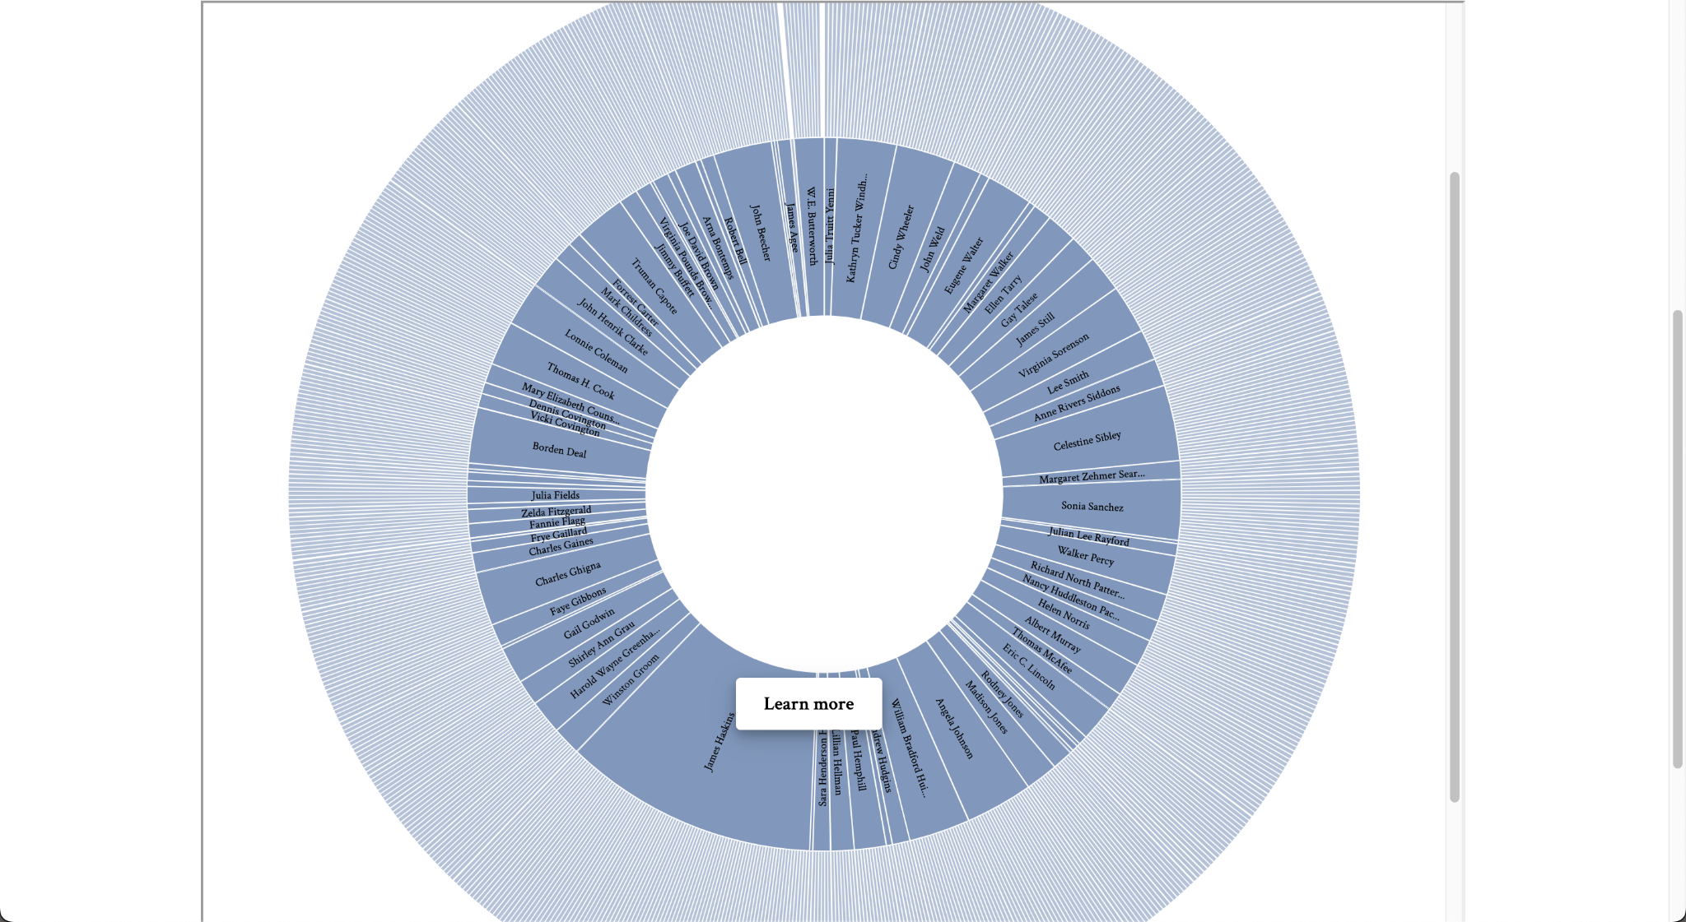

**Figure 23. D3.js Authors & Books Sunburst - Author Context Menu**

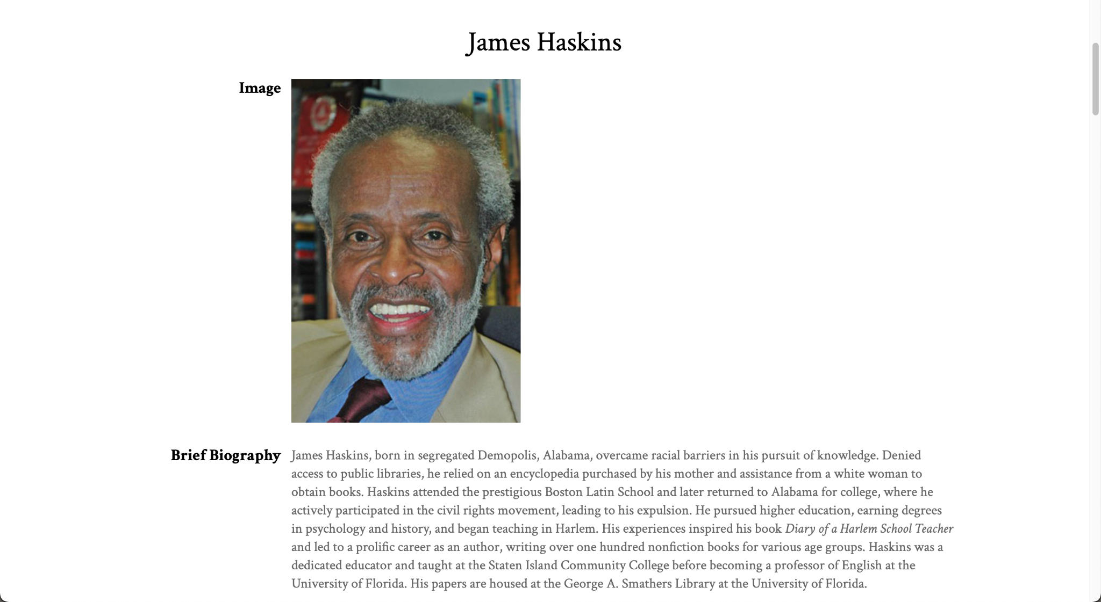

**Figure 24. D3.js Authors & Books Sunburst - Context Menu to Author Details Page**

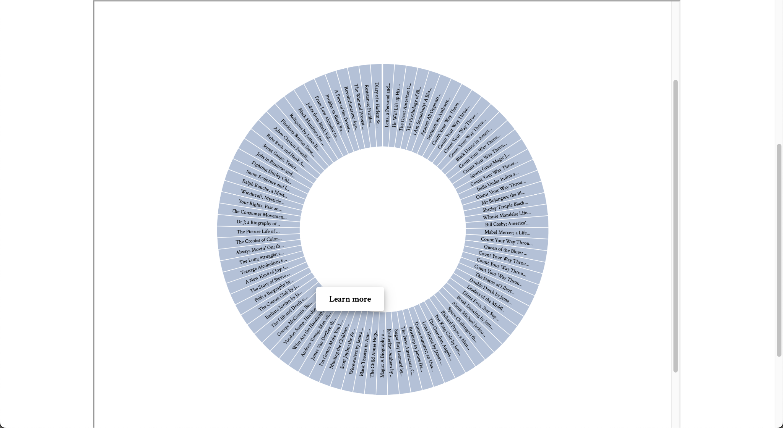

**Figure 25. D3.js Authors & Books Sunburst - Book Publication Context Menu**

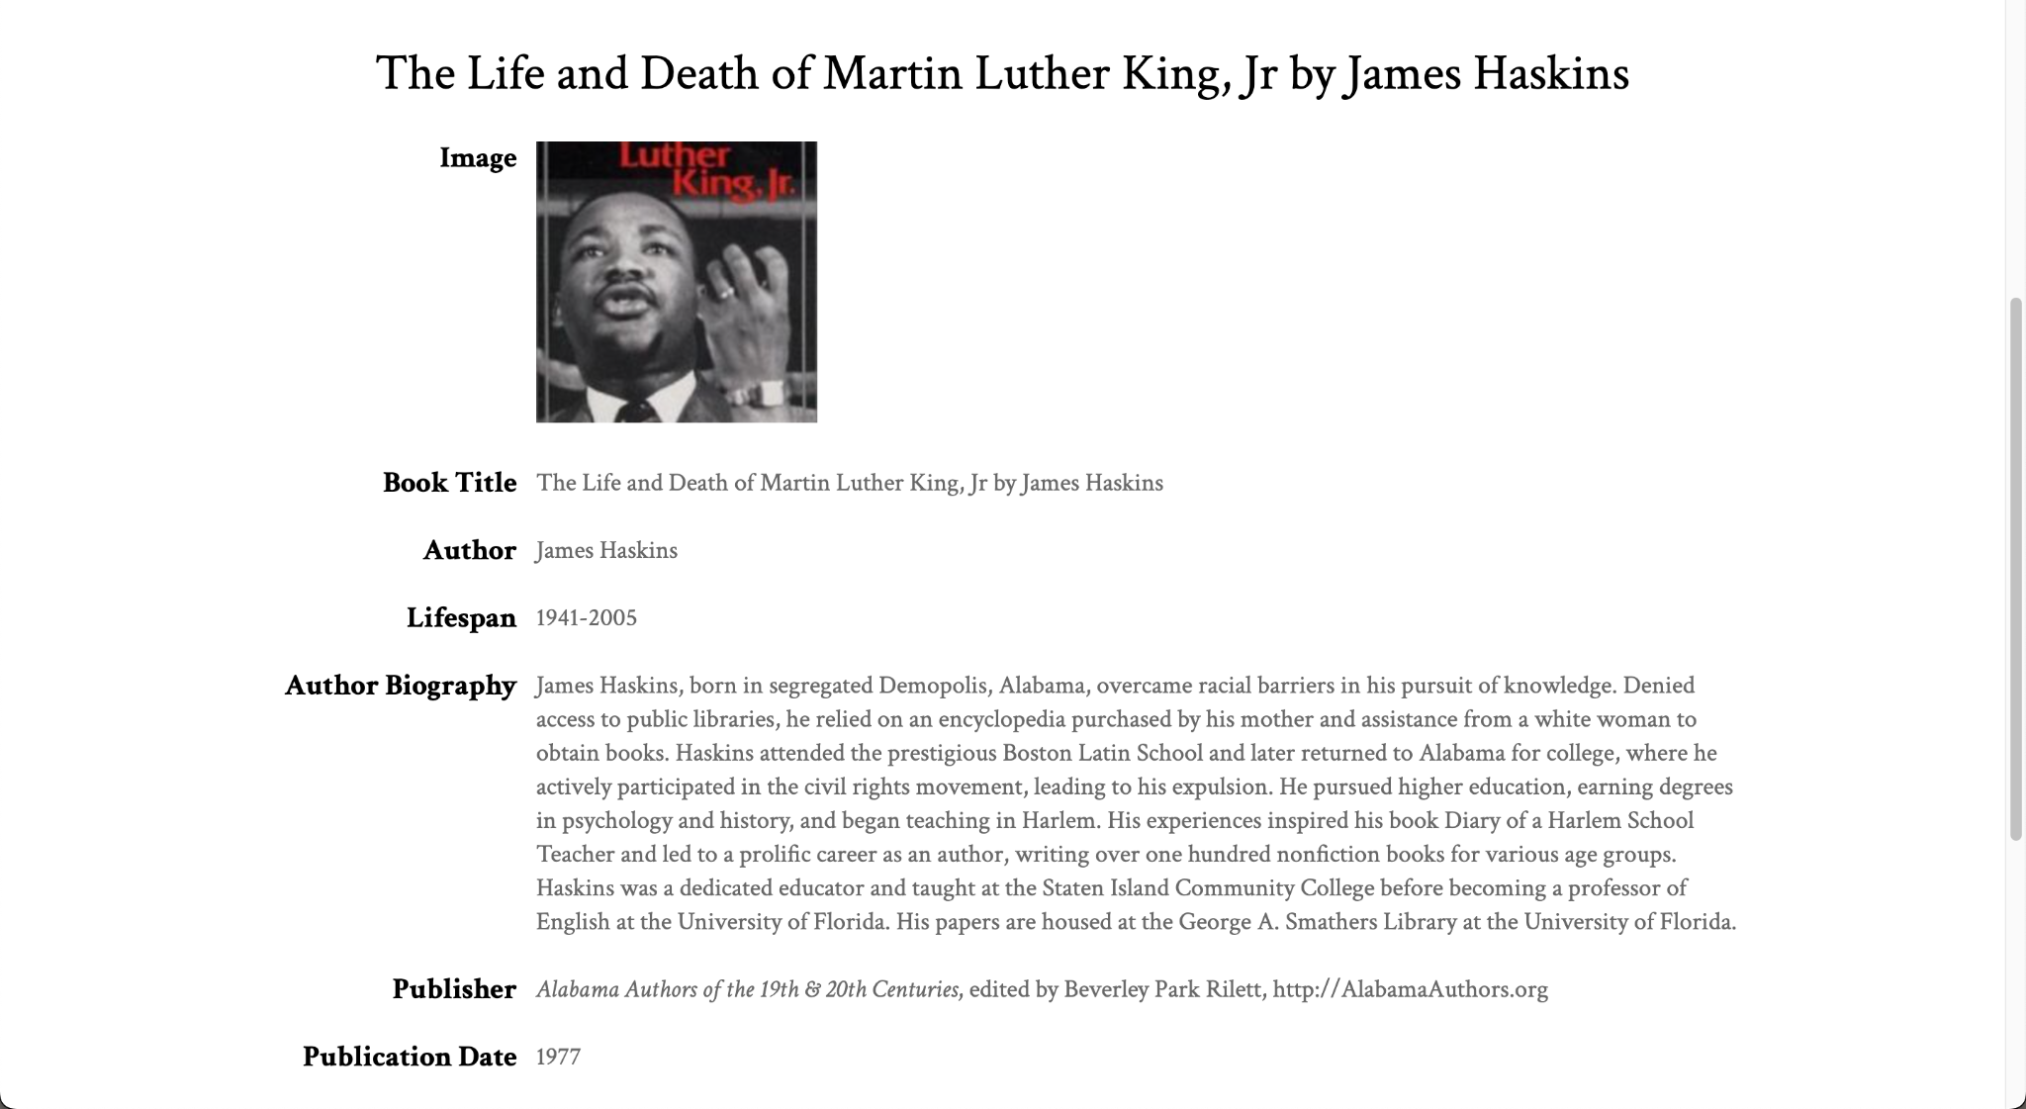

**Figure 26. D3.js Authors & Books Sunburst - Context Menu to Book Publication Details Page**

Keyboard commands are not currently supported for navigating to author or book publication detail pages.

### Export Visualization

Exporting the sunburst view is supported within the visualization. To export the current view, users may utilize the export button at the top right of the visualization. This downloads a PNG image of the sunburst visible on the page to their local computer.

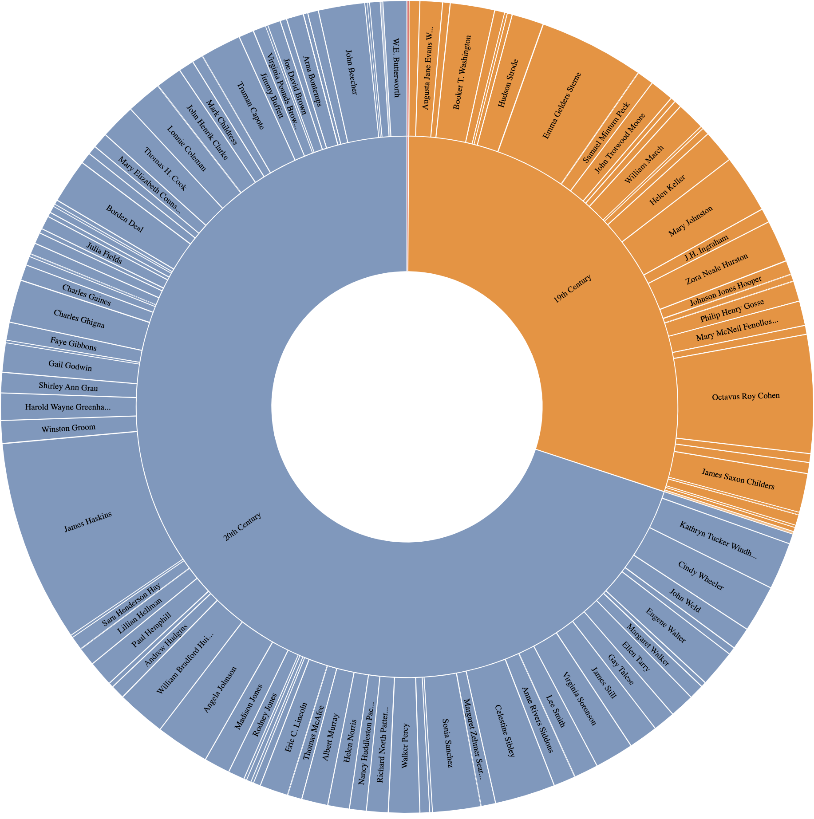

**Figure 27. D3.js Authors & Books Sunburst - Exported Image of Initial View**

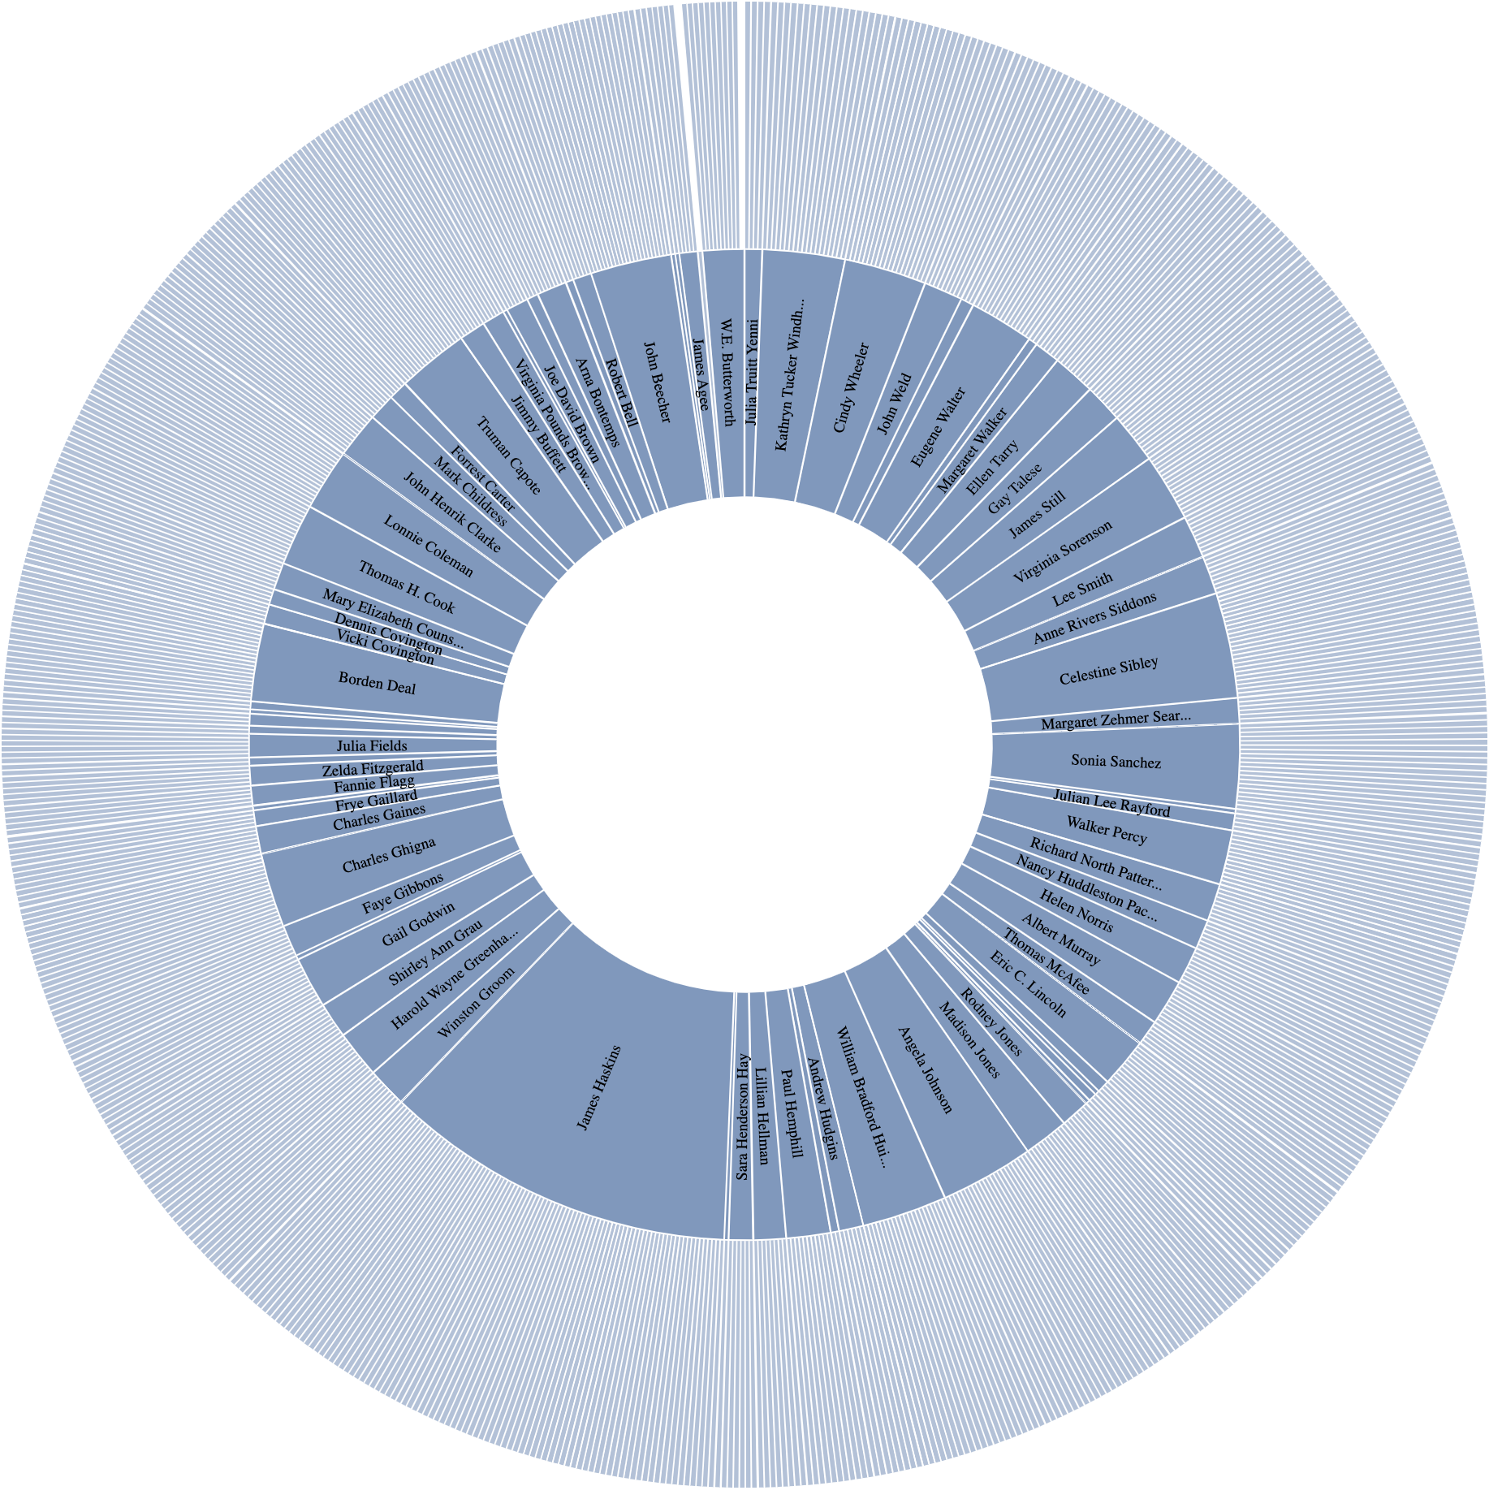

**Figure 27. D3.js Authors & Books Sunburst - Exported Image of 20th Century View**

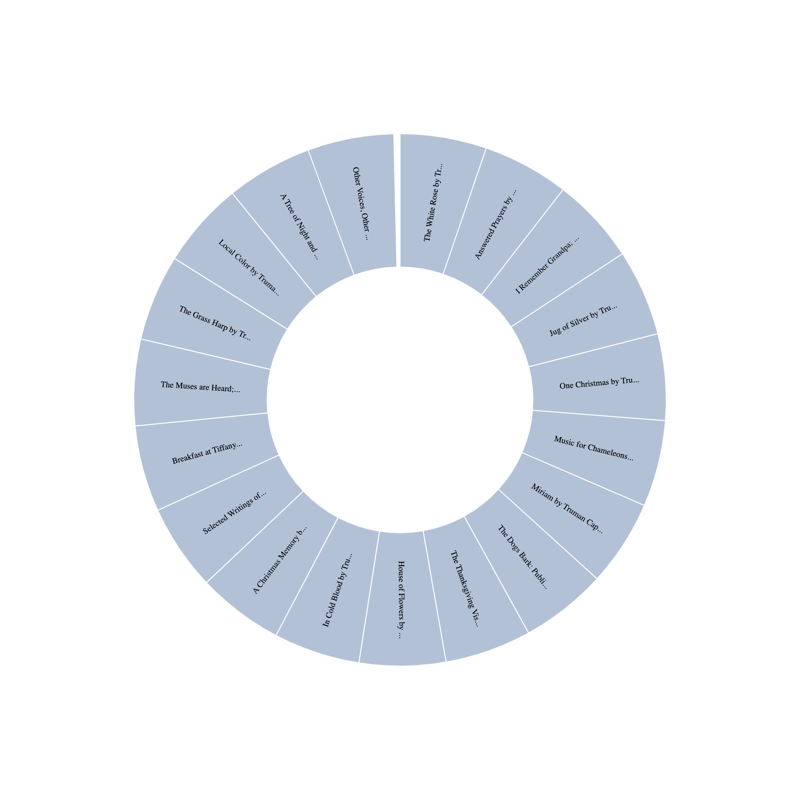

**Figure 28. D3.js Authors & Books Sunburst - Exported Image of Author View**

## **Heatmap: Books**

The Heatmap: Books tab takes users to the Neatline visualization that displays publications from the Book List collection on a calendar wheel. Each wedge on the wheel represents a decade in the nineteenth and twentieth centuries. The publication densities are shown by a color gradient. Darker shades of blue represent a greater amount of publications and lighter shades of blue represent a lesser amount of publications.

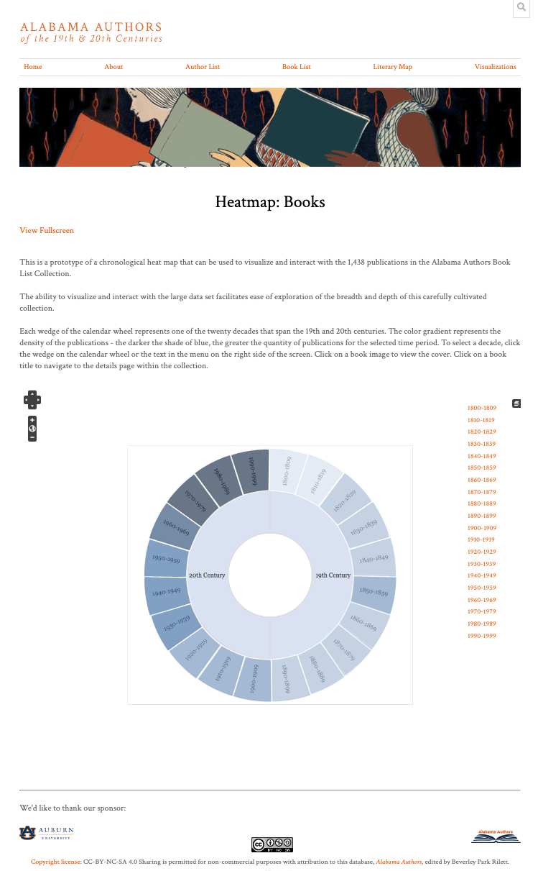

**Figure 29. Neatline Publication Heatmap**

### Navigate Visualization

To navigate the heatmap, users can use their trackpad or the navigation controls in the top left corner to increase or decrease the zoom. Scrolling down zooms out and scrolling up zooms in. Clicking the plus sign in the navigation controls zooms in and clicking the minus sign zooms out. The placement of the image can be adjusted by clicking and dragging the image left, right, up, or down. Image placement can also be adjusted by using the arrows in the navigation controls in the top left corner. Clicking the small globe symbol in the navigation controls resets the image zoom and placement to the default settings.

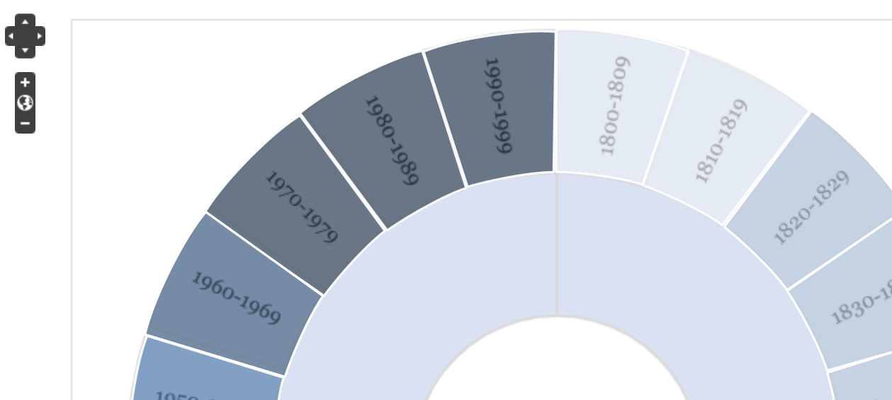

**Figure 30. Neatline Publication Heatmap - Zoomed In with Navigation Controls Displayed In Top Left Corner**

### View Popover

To view the popover for any decade, click the corresponding wedge on the calendar wheel or click the date range in the menu on the right side of the screen. The popover displays basic information about every publication in the collection for the selected period including the book cover image, title, author, and publication year.

### Access Book Cover Image and Details Page

To access the book cover image, users can simply click the image shown in the popover. Similarly, users can click the title and author listed in the popover to access the details page. This will take the user to a new tab with the associated publication details page within the Alabama Authors website.

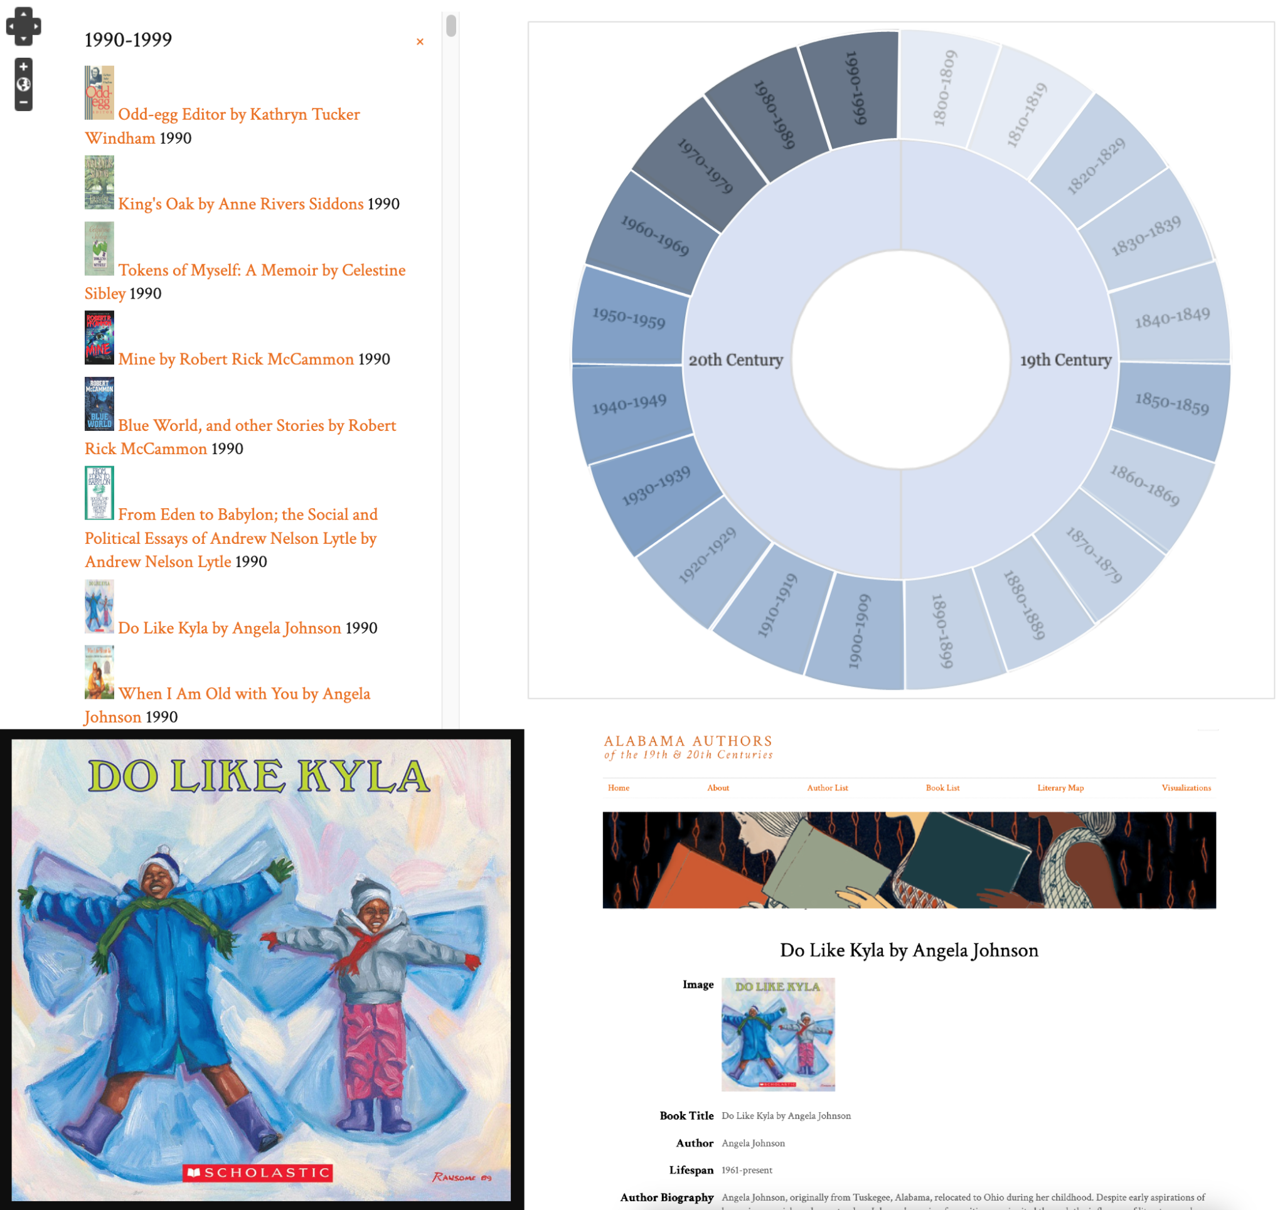

**Figure 31. Neatline Publication Heatmap - Popover Displaying Publication List with Resulting Book Cover Image and Details Page**

# **Tutorials**

Video tutorials of the three data visualizations are accessible at <https://drive.google.com/drive/folders/1ZpPuAKMx67Xy157AjgKUNR-TLC0Nt0D4?usp=sharing>.

Dr. Rilett also has access to these video demonstrations in her Senior Design Team Orange Box folder.